ProSME Website Development Feedback Document (Template B) https://smefund-option-b.vercel.app/

In chronological order of appearance

Home Page
Header
Logo - Use the white logo against an orange background
Header - The header background should be orange
Secondary Menu - Make the content and menus more visible, perhaps make the background white 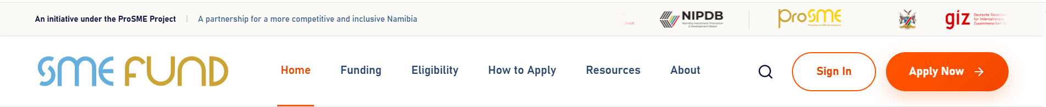

Home Page Body Section
Replace Find Funding button with Apply Now Button
Change Funding and business development support for Namibian SMEs ready to grow to Funding and business development support for Namibian MSMEs ready to grow.
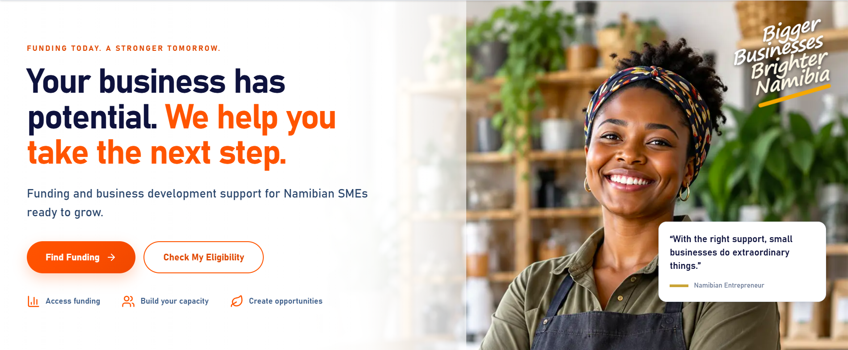

Insert this table from Template A and add the application tracking button below or next to the Apply Now button. The eligibility button is already in the section above. Please change …qualifying Namibian SMEs… to …qualifying Namibian MSMEs…

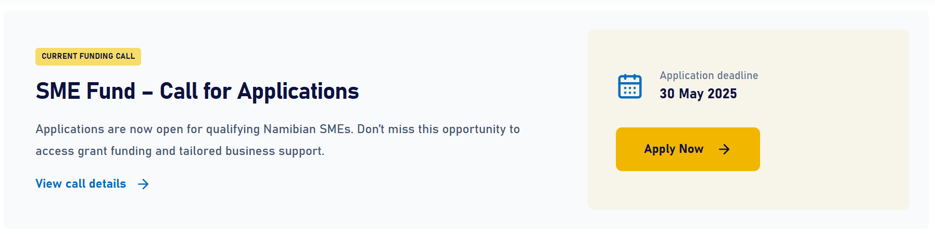

Current Funding Opportunities - replace with Latest News & Resources from Template A
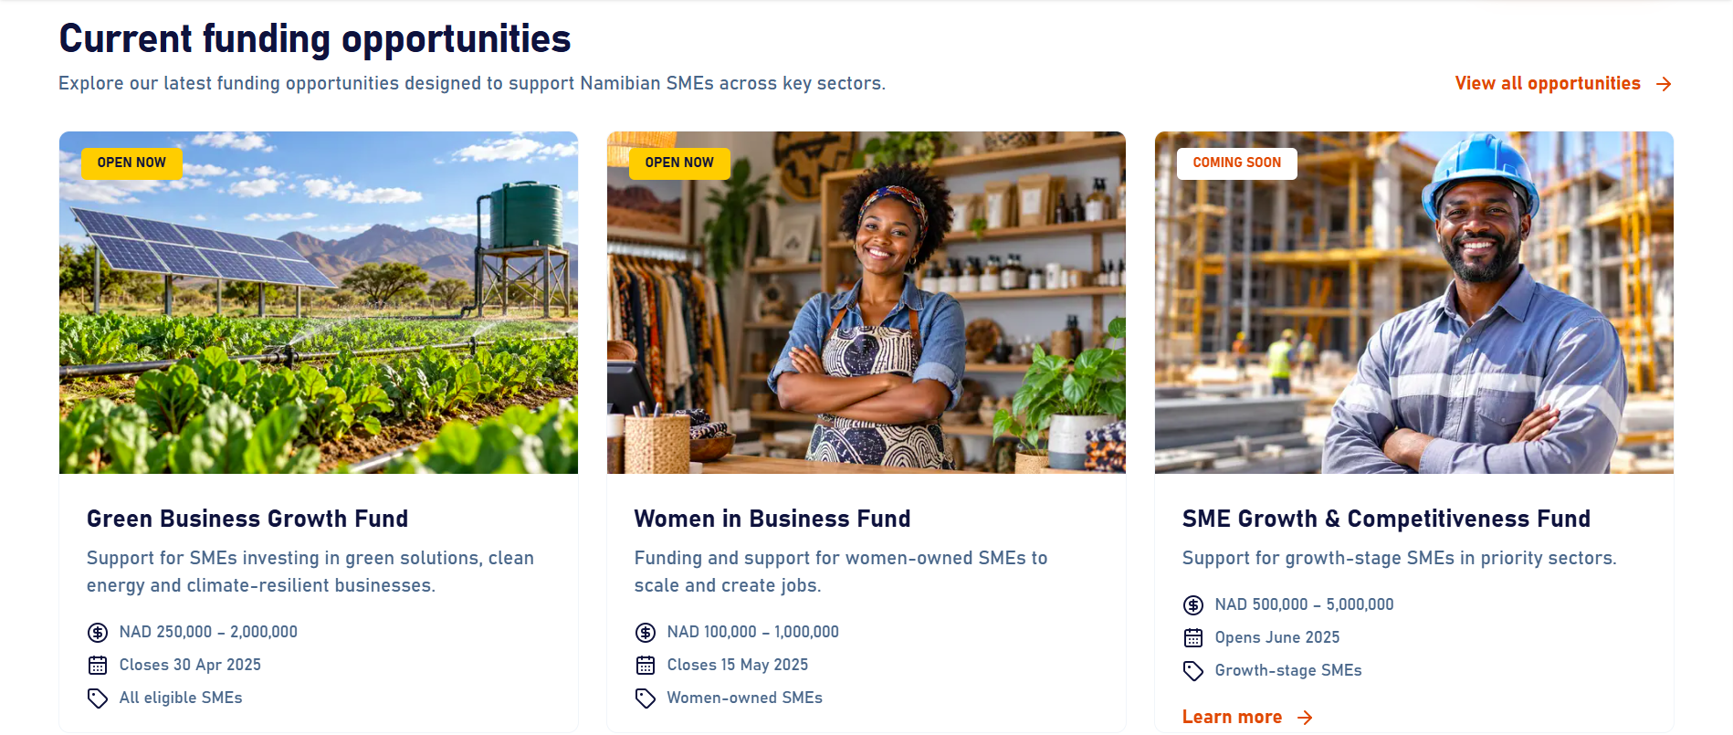
Under the News & Resources section, please upload the funding criteria document: https://smefund.nipdb.com/wp-content/uploads/2026/06/SME-Fund-Website-Call-4-Applications-1_260609_234027.pdf

Who we support
Change We invest in Namibian SMEs with high potential, inclusive impact and a commitment to growth to The SME Fund is open to any Namibian MSME with high potential, inclusive impact and a commitment to growth. Our priority areas include: then slide starts
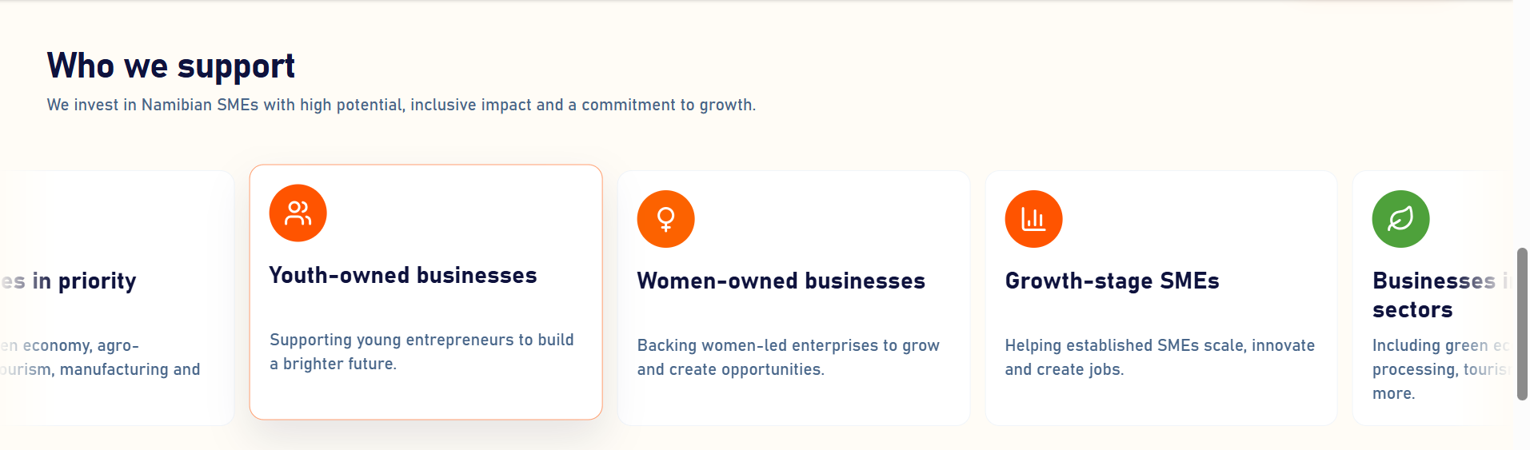

Change:
Real businesses. Lasting impact.
Together, we’re building a more inclusive and competitive Namibia.
To
Real businesses, lasting impact.
Together, we’re building a more competitive Namibia that supports MSME growth.
Please replace the figures under that with: 7 Funding Calls; 14 Regions Covered; N$50,000-N$100,000 Grant Range; 200+ MSMEs Targeted
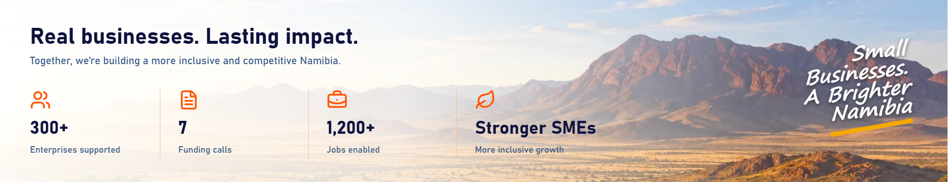

Since we don’t have success stories or insights at this stage, I suggest we remove this section from the website and launch it at a later stage when we have the content.
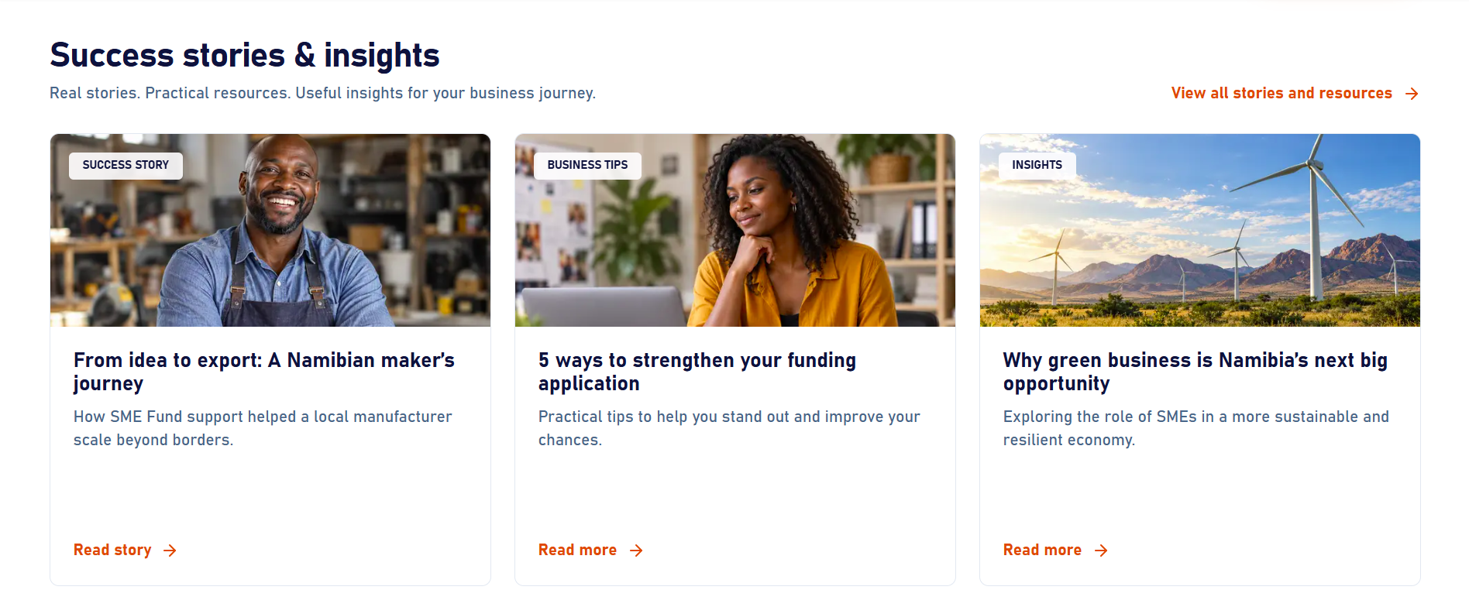

Funding Page
What the fund supports
Change: Funding is intended to strengthen competitiveness, improve productivity and unlock measurable growth—not simply cover routine operating costs.
To: Funding is not intended to simply cover routine operating costs, but to promote growth, competitiveness, and MSMEs’ contribution to Namibia's economic transformation.
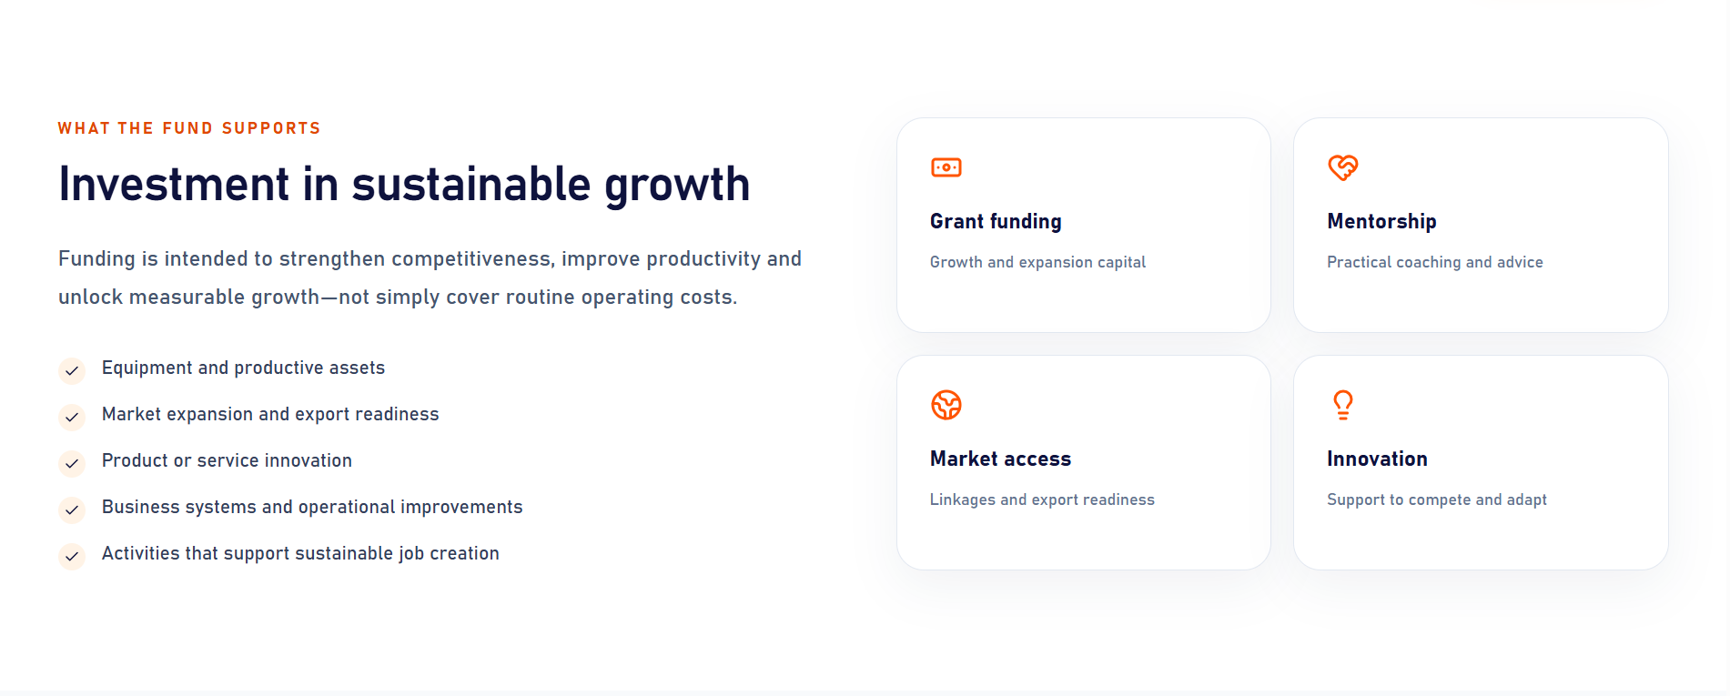

Eligibility Page
Could we include the priority areas on this page, similar to the way they’re listed on the current SME Fund website under Focus Sectors, but in a much smaller grid or other presentation? We could also just use the same presentation from Template A but make it static.


Footer
Copy rights - Should be 2026 not 2025
Contact Us email address: info@smefund.na and link to Contact Us in the footer under support links
The subscribe option doesn't seem to work

General Feedback
Icons - Maintain orange colour consistency for all icons
Font - Increase the body font size
Change all mentions of SME to MSME except where SME is used to refer to SME Fund or ProSME.
FAQ's get them from https://smefund.nipdb.com/ there are some FAQ's with answers
For question 2, please use the following answer:
2. When do applications open and close?
The first call for applications has closed. Please check back soon for the deadlines for the second call for applications.
Replace AI images with real images. I have access to FreePik/Magnific if necessary.
Terms & Conditions & Privacy Policy: the developer should create generic ones and link them

Domain
- The domain name and information is IP: 34.11.75.116; Domain Name: www.smefund.na. The Hosting and access credentials will be shared with the development team by Lenis (send them access/credentials)
- Ensure the site has https/Certificate
- Ensure the website has analytics (Lenis, please assist with this with the developers)

